St Michael’s Church

Chesterton

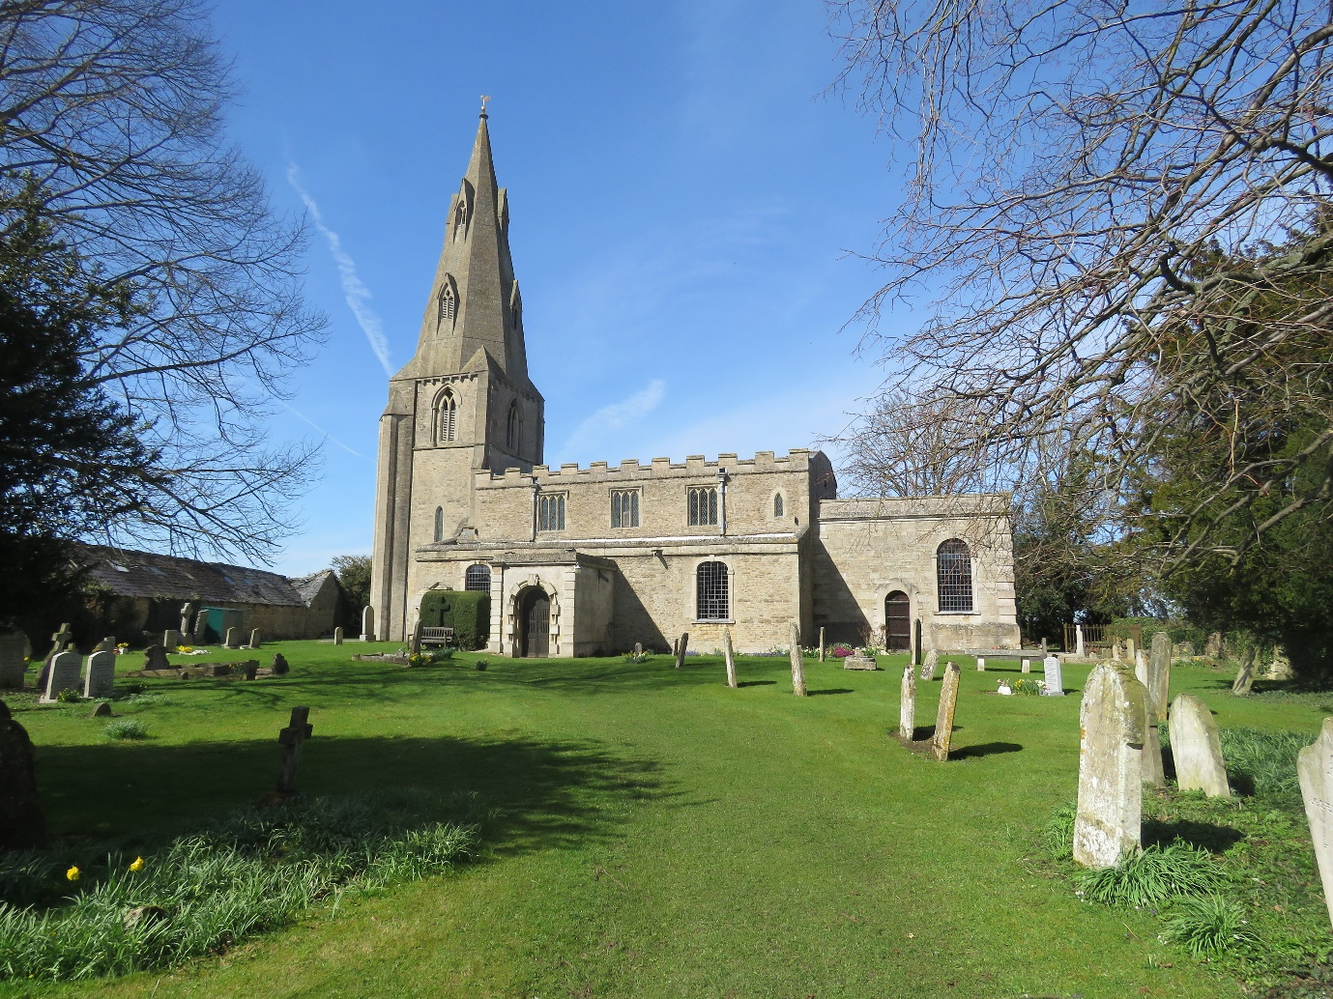

Annual Parochial Church Meeting

2018

Agenda for the Annual Parochial Church Meeting

Thursday 19th April 2018 @ 10am

Annual Parish Meeting
- Election of the Churchwarden(s).

Annual Parochial Church Meeting (APCM)
- Apologies for Absence
- Minutes of the 2017 meeting
- Matters Arising
- The Annual Reports
- The Rector’s Report.
- Report on the Electoral Roll
- Financial Statement for the year ending 31.12.2017
- A report on the fabric of the church
- The Deanery Synod Report.
- Report on the church’s activities.

Elections and Appointments
- PCC committee members.
- Sidesmen
- The Independent Examiner
- Deanery Synod Member

Any other business

Parochial Church Council Meeting
Appointments
- PCC Secretary
- Treasurer
- Electoral Roll Officer

MINUTES OF THE ANNUAL PARISH MEETING HELD ON
THURSDAY 6 APRIL 2017 AT 10.00AM AT ST MICHAEL’S CHURCH

The Reverend Malcolm Ingham welcomed everyone and opened the meeting with a prayer and a reading from Romans chapter 12.

ELECTION OF CHURCHWARDENS

The election of Churchwardens commenced, and Mr John McKee was again elected.

The meeting was then closed.

MINUTES OF THE APCM HELD ON THURSDAY 6 APRIL 2017
AT ST MICHAEL’S CHURCH, CHESTERTON

PRESENT

Chairman: The Reverend Malcolm Ingham
Churchwarden: Mr John McKee

Mrs Jean Hillier, Mrs Audrey Wright, Mr Brian Wright, Mrs D Kotowska, Mrs Helen McKee,
Mr Jim Jones, Mrs Marion Marshall, Mr Colin Marshall.

MINUTES

The Minutes of the 2016 meeting were read and approved, proposed by Mr B Wright,
seconded by Mrs J Hillier and passed unanimously.

MATTERS ARISING

The Reverend M Ingham gave the Annual Report, a copy of which is attached.

Electoral Roll

Mr J McKee reported that there had been a decrease of 2 members and an increase of 1, giving a total of 34 people.

Financial statement

The Financial Statement for 2016 was given by the Treasurer, Mr J McKee, a copy of which is within the Annual report.

Fabric and Buildings

Mr J McKee reported that there are no structural issues with the church building.

In 2017 there will be a full survey of the lighting and heating services.

In preparation for the 2017 Quinquennial the electrical circuits have been fully checked. The initial report shows that some remedial work is required to upgrade some of the wiring to the current standards.

Deanery Synod

Mrs J Hillier gave a report, a copy of which is within the Annual Report.

Prayer mornings

There will be two mornings on 30 and 31 May when the church will be open for private prayer.

Thanks were extended to all members of the congregation who help with church activities throughout the year.

ELECTIONS AND APPOINTMENTS

The following were elected as members of the PCC for the coming year.

Nominee | Proposer | Seconder
Jim Jones | Jean Hillier | Roger Austin
Dorothy Kotowska | Janet Austin | Marion Marshall
Colin Marshall | Arthur Guest | Brian Wright
Marion Marshall | Arthur Guest | Brian Wright
Helen McKee | Jim Jones | John McKee
Brian Wright | Helen McKee | Jim Jones
Audrey Wright | Roger Austin | Janet Austin

Mr Richard Hillier and Mr Roger Austin agreed to continue as Sidesmen.

The Independent Examiner continues to be Mr Michael Cox, proposed by Mr J McKee and seconded by Mr B Wright.

The Deanery Synod representative continues to be Mrs J Hillier, proposed by Mr R Austin and seconded by Mrs Penelope Jones and passed unanimously.

There being no other business, the meeting was closed.

MINUTES OF THE PCC MEETING HELD ON 6 APRIL 2017
AT ST MICHAEL’S CHURCH

PRESENT

Chairman; The Reverend Malcolm Ingham
Churchwarden: Mr John McKee

Mr Jim Jones, Mrs D Kotowska, Mrs M Marshall, Mr C Marshall, Mrs J Hillier,
Mrs H McKee. Mr B Wright, Mrs A Wright

ELECTION OF COMMITTEE OFFICERS

PCC SECRETARY

Mrs H McKee will continue to serve as secretary, proposed by Mrs J Hillier and seconded by Mrs D Kotowska. The motion was passed unanimously.

TREASURER

Mr J McKee was nominated to continue as Treasurer, proposed by Mr J Jones and seconded by Mrs J Hillier. The motion was passed unanimously.

ELECTORAL ROLL OFFICER

Mrs D Kotowska was nominated to take over the role of Electoral Roll Officer, proposed by Mrs J Hillier, seconded by Mr B Wright and passed unanimously.

FABRIC and BUILDINGS

Mr John McKee then proceeded to give a report on the state of the electrics in the church. He reported that:

- The electrical check had failed, and that remedial work was required to bring the electrics back to a serviceable state.
- A quotation had been obtained to replace the current heating and lighting system which was now not fit for use.
- A second quotation was being obtained.

No remedial work would be started until a decision had been made on the replacing of the heating and lighting. This was because if remedial work only was carried out then the cabling to the current overhead heaters was to be replaced.

The DAC would be approached to ensure that all the correct procedures were adhered to and that if necessary a faculty would be obtained.

The Quinquennial would be carried out during the summer but would not be until all remedial or replacement work had been completed.

It was proposed by Mr B Wright and seconded by Mr J McKee that we would transfer the necessary amount from the investment account with the CCLA to fund the works. This proposal was passed unanimously.

Next Meeting

The next PCC meeting would be on Thursday 11th May 2017 at St Michael’s Church.

There being no other business the meeting closed with a prayer.

Reports for 2017

Rector’s Report
Browsing in a bookshop I came across an item called “Find Jesus” – a book a little bit like the “Where’s Wally” series except that here amongst the crowded illustrations it is Jesus that is always present, but hard to find. It’s a bit of fun but there’s an element of truth, as a child Jesus wasn’t where his parents thought he was and his mother told him, “Your father and I have been anxiously searching for you.”

I’m sure it was sometimes very difficult to locate the adult Jesus amongst crowds too, after all remember that Judas had to arrange a signal to show the guards which specific man they were to arrest. Well, if it was sometimes hard to find Jesus 2000 years ago, what about clergy today? We can be a bit elusive too.

Recently I was told that someone had complained that whenever they phoned I wasn’t in, I have no idea who this person is because I have never had a string of messages left on my answerphone from one particular individual frustrated at my absence. Now, although I’m sorry that they weren’t able to speak to me immediately, I have to confess that my heart leapt a little with joy at their complaint. You see, like many of my clergy colleagues, I worry that I actually spend too much of my time in the study dealing with an ever rising tide of admin, so to know that I am getting out and spending time with real people is good news for me and, I hope, for you too.

But what might be the reason your phone call to the Rectory isn’t answered? If there is a little grumbling it is good to address the issue, so allow me to give you a few insights into what might send you straight to the answerphone.

It might be that I am out doing some pastoral visiting; visiting someone who is ill, or in need, someone who has questions or has asked for prayer. They might have been recently bereaved or be in hospital. I may be visiting the next of kin to arrange a funeral or taking a funeral service which might not only be at one of our churches but then continue at the crematorium or I could be in one of our churchyards conducting an internment of ashes.

On a happier note I might be taking a wedding or meeting with a wedding couple or preparing parents or candidates for baptism. My study is also where St. Andrew’s PCC meetings take place and where people call round to talk with me about something on their mind or heart and if I’m in a meeting like this, even if it is in my study, I will usually allow any calls to go straight to the answerphone as it is not always appropriate to deal with a phone call (which might be lengthy or of a personal nature) with an audience present.

I have various commitments at a local, deanery, diocesan and national level which takes me out of the study, for example I am part of the Churches Together in the Orton’s committee and these planning meetings lead onto events which need to be attended. In the Anglican context we often meet as deanery clergy to pray for and support one another as well as share news and plan. There are deanery clergy Chapter meetings and Deanery Synod which is connected to my role on Diocesan Synod over in Ely. Ely is also the venue I have to attend for the Clergy Wellbeing forum chaired by Bishop David which I have been on for some while, a group which seeks the help clergy in our diocese flourish and it is also where the Diocesan Kigali steering Group meets. This group deals with our diocesan link with Kigali diocese in Rwanda and I was privileged to be invited to join it.

Alternatively I might be in a meeting at Cambridge where I am part of the local Renew group for clergy who support one another and think strategically about how to be faithful Gospel centred Churches that are growing. I have also been on the steering group for the Diocesan Evangelical Fellowship for a number of years; a group which also meets in Cambridge.

Further afield I was invited some time ago to join the Church Mission Society (CMS) Africa forum which meets in Oxford. This means I have an input into the wider church but also feeds back into St. Andrew’s support of CMS. Then again, from time to time, I may be away for a day or two at a training event, conference or retreat to inform, refresh and equip my ministry and therefore the ministry of our fellowships.

Closer to home I might out leading the Tiddlywinks preschool group, taking home Communion to someone, be at a church event or leading collective worship for our local school. I might be hosting a group from the school, or local preschool at the church, leading Christianity Explored, preparing candidates for Confirmation, or at St. Michael’s PCC.

And this is just the tip of the iceberg, as I write, I am aware of so many other regular, occasional and one-off events, meetings and calls on my time that take me away from the study in the morning, afternoon and evening.

So, clergy work quite hard. In fact I was recently poorly, more ill than I had been at any other time in the thirteen years that I have been Rector here, but once I was well enough to get back to work my “recuperation” was to work eight straight days before I was able to take a first day off and then a further ten days before my second rest day and then another eight day stretch.

Please also remember that I am a husband and father, so if I am not available when you call then I might be enjoying a family day out or with my children ferrying them to work, a sports fixture or on the school run and, just like you I have to engage in those everyday tasks such as taking the car in for a service, popping to the shops for essentials (we get through a lot of tea, coffee and milk with all the meetings), going into the bank or attending a doctor’s appointment.

Like telephone marketing companies most us know a good time to catch someone in is lunch or dinner time, but it might also be the only time that I get to sit down with my family and share a meal with them before the evening’s meeting begins. Alternatively I could be at a crucial point preparing a food. And, yes, clergy are human too – we do have to go to the toilet sometimes and it’s not unknown for the phone to ring when we do.

So, where is the Rector? Sometimes I’m in my study and available, sometimes I’m there but not able to answer the phone and Sometimes I will be elsewhere and I’m pleased that this is the case, I believe that if I was only ever tucked away in the Rectory I would not be serving our parishes well at all. So, send me an email, pop round for a chat or if you like, call me, but if I’m not in when you want me then it is always possible to leave your name, number and a brief message on the answerphone and I promise that I will get back to as soon as I’m able to.

Fortunately the Church doesn’t just have one member - it isn’t all about what the Rector does, I’m not even the head of the Church – that’s Jesus, I’m just one member, one part of the body (as the Bible puts it) with all of us working together for the glory of God, so, let’s read the rest of this Annual Report and thank God for his blessing upon all the amazing things the rest of you have been up to when you’ve not been in my study either.

Reverend Malcolm Ingham
Rector

Financial Report
During 2017 there was nor major expenditure. The church finances ended the year with an increase in the overall balance that the balance at the start of the year. This increase was achieved by the returns on the 2 CCLA Equity Accounts which grew by over 11%.

Church expenditure exceeded income, but this was down to the installation of the roof alarms. The cost of the roof alarms will be partly paid by the £2000 grant we received from the Historic Churches Trust.

The installation of the roof alarms will also reduce our insurance premium by over 10%.

During 2018 it is essential that we constantly check that our income is sufficient to cover the mandatory monthly expenditure.

The financial position of the church as of 31 December 2017 is sound although 2018 will be a testing time as we refurbish the heating, lighting and electrical systems.

- Full financial details are in the annual accounts.
- Church Insurance now paid monthly rather than annually.
- The overall position is an improvement over 2016.
- Expenditure was higher in 2017 than income.
- Charitable Giving was10% of our income.

The income was increased to meet the expenditure by the transferring of capital from the CCLA deposits. Care must be taken to ensure that the deposits are not depleted by being used for current expenditure.

John McKee
Treasurer

Report on the Electoral Roll
The number of people on the Electoral Roll is 34. This is unchanged from 2016.

We have had new people in the congregation this year, but they have left before the required time for entering them on the roll.

Dorothy Kotowska
Electoral Roll Officer.

Church Activities in 2017

Fairtrade 2017
Unfortunately this year we ceased trading as our supplier had to retire due to ill health. When all was wound up £100 was given to the church, £30 was sent to 5talents, and £4.75 was added to our Flower fund for the Flower Festival.

Lent lunch
In March we hosted a Lent lunch as part of the series of Lent lunches throughout the Ortons. Our talk on inspirational people was about Julian of Norwich, a 14th century anchoress. The lunch was well attended, there being 30 people. It appeared to be enjoyed by providers and recipients. Donations were made and these were given to the Mothers’ Union to be used to empower women in Africa.

Coffee Mornings
Each month between May and September we held a coffee morning on behalf of the Women’s Refuges in Peterborough and Huntingdon. We raised £399. 34 and so £200 was sent to each establishment. In Peterborough the money went to Women’s Aid, who run the refuge. Some people attended the AGM and heard more about the work of Peterborough Women’s Aid. The money for the refuge in Huntingdon was sent via the Diocesan Mothers’ Union. Another reason for the Coffee mornings was to give local people somewhere to meet and talk. This seemed to be appreciated. The coffee and cakes were free and people made a donation on the way out. Our numbers were quite low at the beginning but by September there was a real buzz about the church during the Coffee morning.

Flower Festival
In June we held a Flower Festival which brought members of the church together for a common cause. Our theme was favourite hymns. It was a tiring experience but enjoyable. Unfortunately, we clashed with many other events and our visitors were sparse, but very appreciative of the beautiful flowers. However our Songs of Praise on the Sunday evening was well attended.

Jean Hillier

Yaxley Deanery Synod Report 2017

This past year the way of conducting the meetings of the Deanery Synod has changed. Business was kept to a minimum and the talks, when there were talks, led to short discussions, and then the whole point of the evening was the telling of “Good News” stories from around the Deanery.

The Synod is also awaiting the production of a Pastoral plan which will then be ready for discussion.

February 2017
In February we met at Christ Church where, after opening worship and the authorising of Authorised Lay Ministers. There was a discussion about opening our churches, in some cases for 24 hours, to allow quiet prayer times.

We were then given a talk by Ed Olsworth Peter on Pioneers, Pioneering and Fresh Expressions. He was keen for churches to have a dialogue with the people in their area to find out what they wanted from the local church.

June 2017
At Stilton in June Rev. Peter Wood (Director of Mission) and Rev. Linda Church (Director of Ministry) spoke of the resources and training available in the Diocese to help churches engage with the diocesan strategy “We pray to be a generous and visible people of God”. There was a DVD of Bishop Stephen and then group discussion. There is an Ely 2025 Mission Fund to invest in the future. This can be a one-off payment of £3k, or up to £20k for 3 years.

Sylvia Kinder from Christ the Servant King told us how they had applied for some funding and were given a grant to enable them to employ a part time children and family worker and a part time youth worker.

John Randall reported that Mark Fuller, who had been a pioneering curate at Yaxley will be moving to be Team Vicar in Portishead in September.

October 2017
At the meeting at St. Michael’s, Stanground, there was a relicensing for Jake Ellard to the Orton churches, an appointment of a pioneer minister to Christchurch, and the appointment of the Rev. Imogen Falvey as a non-stipendiary minister to the Orton parishes. Rev. Donald MacFadyen is leaving Sawtry to concentrate on preparing the notes of his former tutor for publication.

There was a mention of “Soul Survivor” which had been a Christian gathering at the showground for young people. It had been a resounding success.

The good news stories included Rachel Hilditch speaking about her work with young people in Hampton, the Stilton group gaining an Administrator. Stanground have an Administrator for 3 years and Yaxley now have an Administrator.

Jean Hillier
Deanery Synod Representative
Fabric and Buildings
Overall the fabric of the church is in good condition and there has been no requirement or need for any major refurbishment or repair.

2017 was the year of the quinquennial inspection and as part of this inspection the electrical system was fully checked. The Quinquennial inspection raised several points that would require some remedial work in the future. The details of all areas inspected are detailed within the report which is available on request. Immediate work or observations are as follows:

The inspection raised concerns about the floor of the belfry. There are signs of beetle infestation in one area of the floor. To ensure that this did not cause any immediate problems the door to the tower has been locked. The floor and beams will be monitored to ensure that there is no further deterioration.

The trapdoor to the ringing platform is classed as unsafe due to the poor quality of the bolts. A steel rod has been fitted to ensure that the door cannot open under its own weight.

The water butt was removed as the overspill was creating damp against the church wall.

The door in the chancel should have a weather bar fitted to prevent the entry of rainwater.

As part of the Quinquennial inspection a full electrical check was carried out. This raised several points which required remedial work.

As this remedial work involved replacing cabling and heaters the PCC decided to replace the current hearting with a modern system which would make the church more comfortable in the winter. This involves:

- The removal of the current overhead heaters.
- The 4 rear overhead heaters will be replaced by halogen heaters.
- The removal of the current pew heaters.
- The pew heaters will be replaced by new heaters providing warm air.
- All current cabling not meeting the requirements of the current electrical regulations will be removed, upgraded and/or replaced.

The Archdeacon has provided a certificate authorising that this work, upgrading of the heating, to proceed.

During 2017 the roof and church was protected by the installation of an alarm system. The roof is now alarmed which provides protection against metal thieves. Entry to the church is by a Key Fob, of which there are 5 fobs. Entry to the church requires the un-setting of the alarm when entering and the setting of the alarm when exiting the church. This allows entry to the church to be monitored giving the knowledge that we will know who entered the church and when.

John McKee
Churchwarden
Charitable Giving
Over 10% of our income is used for Charitable purposes. During 2017 we supported the following:

- The Mothers Union.
- Specific donations being used to support Mothers Union activities in Africa.
- The Women’s Refuges in Peterborough and Huntingdon.

In addition to the above we continued to support the Peterborough Food Bank. The aim in 2018 is that rather than make small donations weekly, the donations would be made monthly. The aim is for us provide sufficient donations of food to support the requirements of a family.

Helen McKee
PCC Secretary

